Problem Statement:
- Analytics Vidhya conducted an assessment test to hire a Data Scientist. The candidates were evaluated on 5 different subjects A, B, C, D, and E. The marks of 5 different subjects out of 100 are given below. Help Analytics Vidhya to find out the answers of the following questions.

- Who scored the highest marks in the subject B?
- What is the average marks scored in the subject C?
- Who scored the highest percentage of marks?
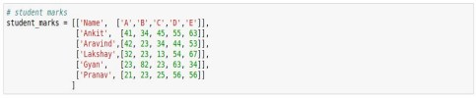
- If considered only top-4 subjects of a candidate, then who scored the highest percentage of marks?

- Who scored the highest marks in Subject B?

Answer : Gyan scored the highest in Subject B with 82 marks.

2. What is the average marks scored in Subject C?

Answer : Average = (45 + 34 + 13 + 23 + 25) / 5 = 28

- Who scored the highest percentage of marks?

Answer :Akhil scored the highest percentage with 238/500 = 47.6%.

4. Considering only the top 4 subjects of each candidate, who
scored the highest percentage?

Answer :Akhil scored the highest with 204/400 = 51.0%.

